Lab 5.5.3: Troubleshooting Spanning Tree Protocol (Solution)

Topology Diagram

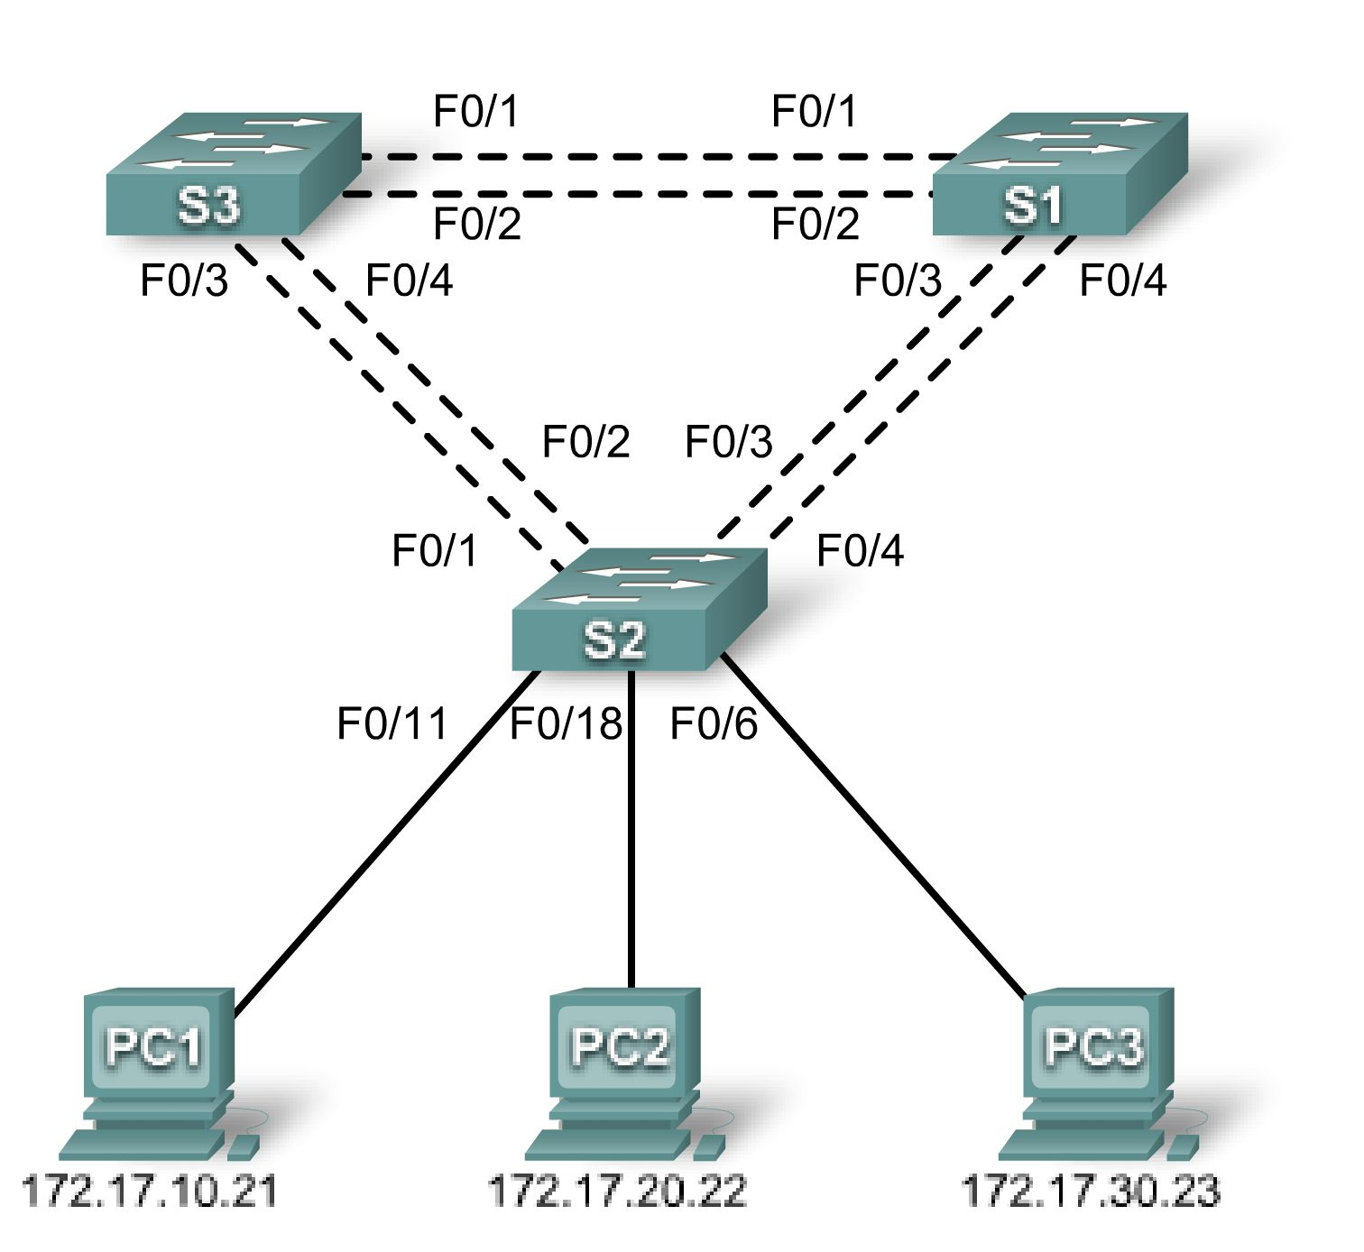

Addressing Table
Device  (Hostname) | Interface | IP Address | Subnet Mask | Default Gateway
S1 | VLAN 99 | 172.17.99.11 | 255.255.255.0 | N/A
S2 | VLAN 99 | 172.17.99.12 | 255.255.255.0 | N/A
S3 | VLAN 99 | 172.17.99.13 | 255.255.255.0 | N/A
PC1 | NIC | 172.17.10.21 | 255.255.255.0 | 172.17.10.1
PC2 | NIC | 172.17.20.22 | 255.255.255.0 | 172.17.20.1
PC3 | NIC | 172.17.30.23 | 255.255.255.0 | 172.17.30.1

Port Assignments – Switch 2

Ports | Assignment | Network
Fa0/1 – 0/4 | 802.1q Trunks (Native VLAN 99) | 172.17.99.0 /24
Fa0/5 – 0/10 | VLAN 30 – Guest (Default) | 172.17.30.0 /24
Fa0/11 – 0/17 | VLAN 10 – Faculty/Staff | 172.17.10.0 /24
Fa0/18 – 0/24 | VLAN 20 – Students | 172.17.20.0 /24

Learning Objectives
Upon completion of this lab, you will be able to:
- Analyze a congestion problem in a redundant, switched LAN network.
- Recognize the capabilities for per-VLAN load balancing with PVST.
- Modify the default STP configuration to optimize available bandwidth.
- Verify that modifications have had the intended effect.
Scenario
You are responsible for the operation of the redundant switched LAN shown in the topology diagram. You and your users have been observing increased latency during peak usage times, and your analysis points to congested trunks. You recognize that of the six trunks configured, only two are forwarding packets in the default STP configuration currently running. The solution to this problem requires more effective use of the available trunks. The PVST+ feature of Cisco switches provides the required flexibility to distribute the inter-switch traffic using all six trunks.
This lab is complete when all wired trunks are carrying traffic, and all three switches are participating in per-VLAN load balancing for the three user VLANs.
Task 1: Prepare the Network
Step 1: Cable a network that is similar to the one in the topology diagram.
You can use any current switch in your lab as long as it has the required interfaces shown in the topology diagram. The output shown in this lab is based on Cisco 2960 switches. Other switch models may produce different output.
Set up console connections to all three switches.
Step 2: Clear any existing configurations on the switches.
Clear NVRAM, delete the vlan.dat file, and reload the switches.
Step 3: Load the switches with the following script:

S1 Configuration

hostname S1
enable secret class
no ip domain-lookup
!
vtp mode server
vtp domain Lab5
vtp password cisco
!
vlan 99
name Management
exit
!
vlan 10
name Faculty/Staff
exit
!
vlan 20
name Students
exit
!
vlan 30
name Guest
exit
!
interface FastEthernet0/1
switchport trunk native vlan 99
switchport mode trunk
no shutdown
!
interface FastEthernet0/2
switchport trunk native vlan 99
switchport mode trunk
no shutdown
!
interface FastEthernet0/3
switchport trunk native vlan 99
switchport mode trunk
no shutdown
!
interface FastEthernet0/4
switchport trunk native vlan 99
switchport mode trunk
no shutdown
!
interface range FastEthernet0/5-24
shutdown
!
interface GigabitEthernet0/1
shutdown
!
interface GigabitEthernet0/2
shutdown
!
interface Vlan99
ip address 172.17.99.11 255.255.255.0
no shutdown
!
line con 0
logging synchronous
password cisco
login
line vty 0
no login
line vty 1 4
password cisco
login
line vty 5 15
password cisco
login
!
end

S2 Configuration

hostname S2
!
enable secret class
no ip domain-lookup
!
vtp mode client
vtp domain Lab5
vtp password cisco
!
interface FastEthernet0/1
switchport trunk native vlan 99
switchport mode trunk
no shutdown
!
interface FastEthernet0/2
switchport trunk native vlan 99
switchport mode trunk
no shutdown
!
interface FastEthernet0/3
switchport trunk native vlan 99
switchport mode trunk
no shutdown
!
interface FastEthernet0/4
switchport trunk native vlan 99
switchport mode trunk
no shutdown
!
interface range FastEthernet0/5 - 10
switchport access vlan 30
switchport mode access
!
interface range FastEthernet0/11 - 17
switchport access vlan 10
switchport mode access
!
interface range FastEthernet0/18 - 24
switchport access vlan 20
switchport mode access
!
interface fa0/6
no shutdown
interface fa0/11
no shutdown
interface fa0/18
no shutdown
!
interface Vlan99
ip address 172.17.99.12 255.255.255.0
no shutdown
!
line con 0
password cisco
logging synchronous
login
line vty 0 4
password cisco
login
line vty 5 15
password cisco

S3 Configuration

hostname S3
!
enable secret class
no ip domain-lookup
!
vtp mode client
vtp domain Lab5
vtp password cisco
!
interface FastEthernet0/1
switchport trunk native vlan 99
switchport mode trunk
no shutdown
!
interface FastEthernet0/2
switchport trunk native vlan 99
switchport mode trunk
no shutdown
!
interface FastEthernet0/3
switchport trunk native vlan 99
switchport mode trunk
no shutdown
!
interface FastEthernet0/4
switchport trunk native vlan 99
switchport mode trunk
no shutdown
!
interface range FastEthernet0/5 - 10
switchport access vlan 30
switchport mode access
!
interface range FastEthernet0/11 - 17
switchport access vlan 10
switchport mode access
!
interface range FastEthernet0/18 - 24
switchport access vlan 20
switchport mode access
!
interface Vlan99
ip address 172.17.99.13 255.255.255.0
no shutdown
!
line con 0
password cisco
login
line vty 0 4
password cisco
login
line vty 5 15
password cisco
login
end
Task 2: Configure Host PCs
Configure the Ethernet interfaces of PC1, PC2, and PC3 with the IP address, subnet mask, and gateway indicated in the addressing table.
Task 3: Identify the Initial State of All Trunks
On each of the switches, display the spanning tree table with the show spanning-tree command. Note which ports are forwarding on each switch, and identify which trunks are not being used in the default configuration. You can use your network topology drawing to document the initial state of all trunk ports.
Task 4: Modify Spanning Tree to Achieve Load Balancing
Modify the spanning tree configuration so that all six trunks are in use. Assume that the three user LANs (10, 20, and 30) carry an equal amount of traffic. Aim for a solution that will have a different set of ports forwarding for each of the three user VLANs. At a minimum, each of the three user VLANs should have a different switch as the root of the spanning tree.
Task 5: Document the Switch Configuration
When you have completed your solution, capture the output of the show run command and save it to a text file for each switch.
Task 6: Clean Up
Erase the configurations and reload the switches. Disconnect and store the cabling. For PC hosts that are normally connected to other networks (such as the school LAN or to the Internet), reconnect the appropriate cabling and restore the TCP/IP settings.

Solution

There are a number of different ways that load balancing can be accomplished. One of the most direct is the following:

S1(config)#spanning-tree vlan 10 priority 4096
S1(config)#spanning-tree vlan 20 priority 16384
S2(config)#spanning-tree vlan 20 priority 4096
S2(config)#spanning-tree vlan 30 priority 16384
S3(config)#spanning-tree vlan 30 priority 4096
S3(config)#spanning-tree vlan 10 priority 16384

